Name: Sri Sai Kowshik Reddy Boyalla

UIN: 734003625

1. Home page

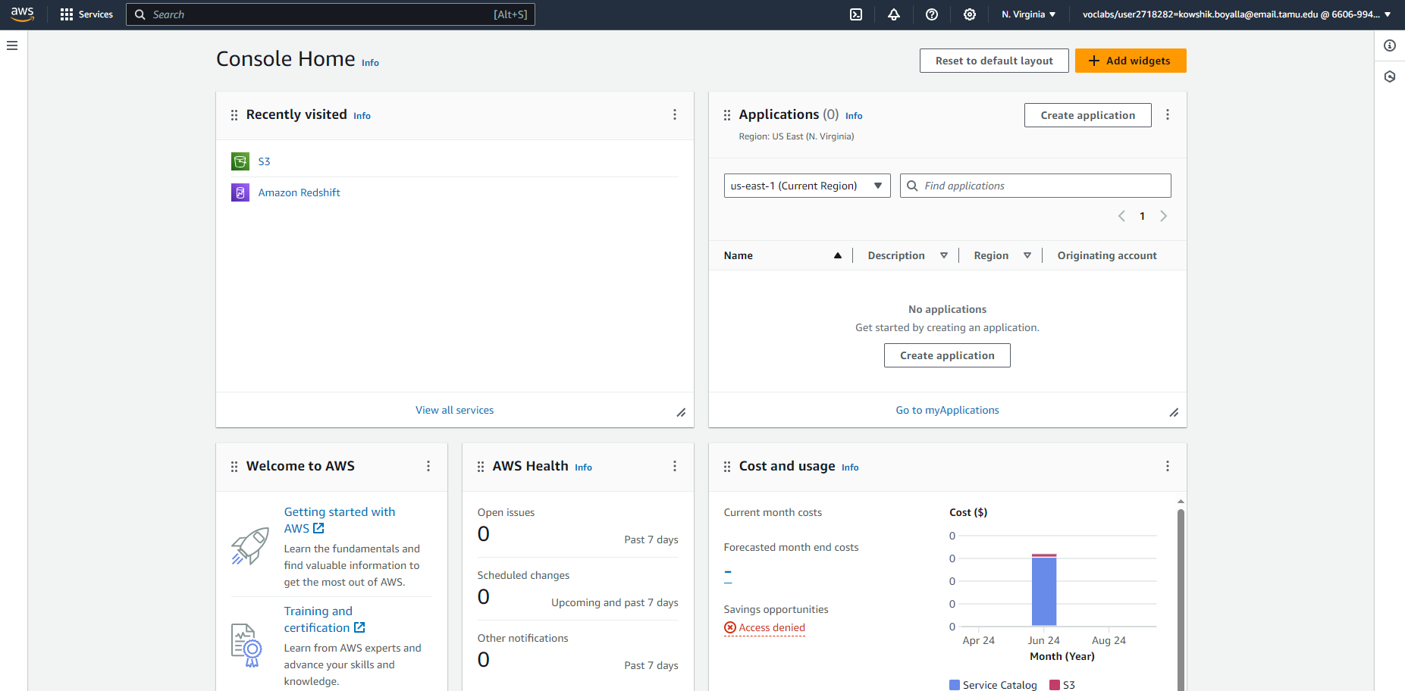

1. Creating a bucket - Name - kowshik

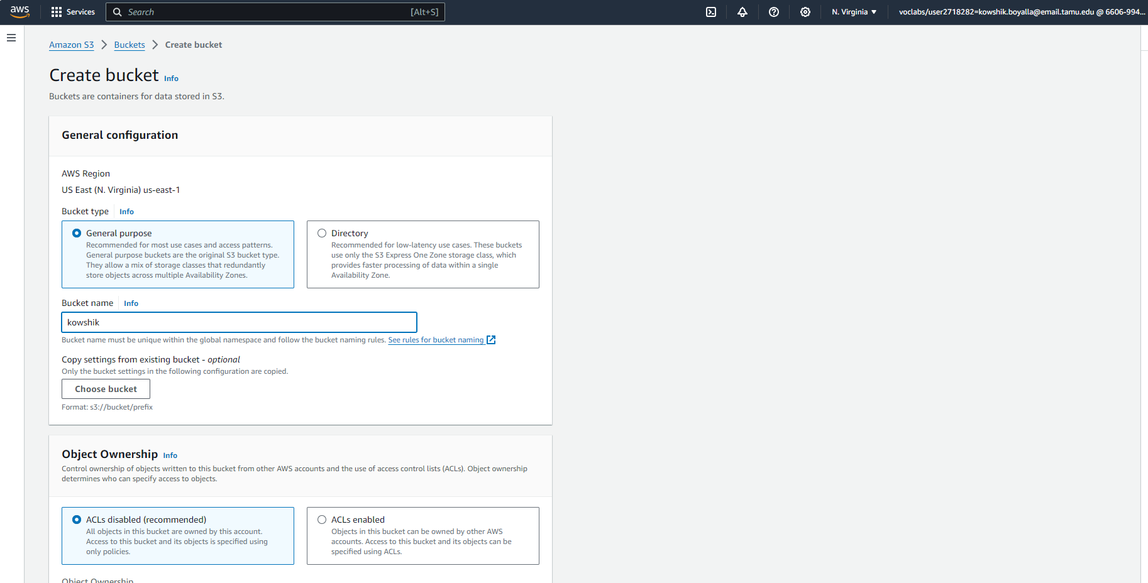

1. After creating the bucket. (Created bucket successfully)

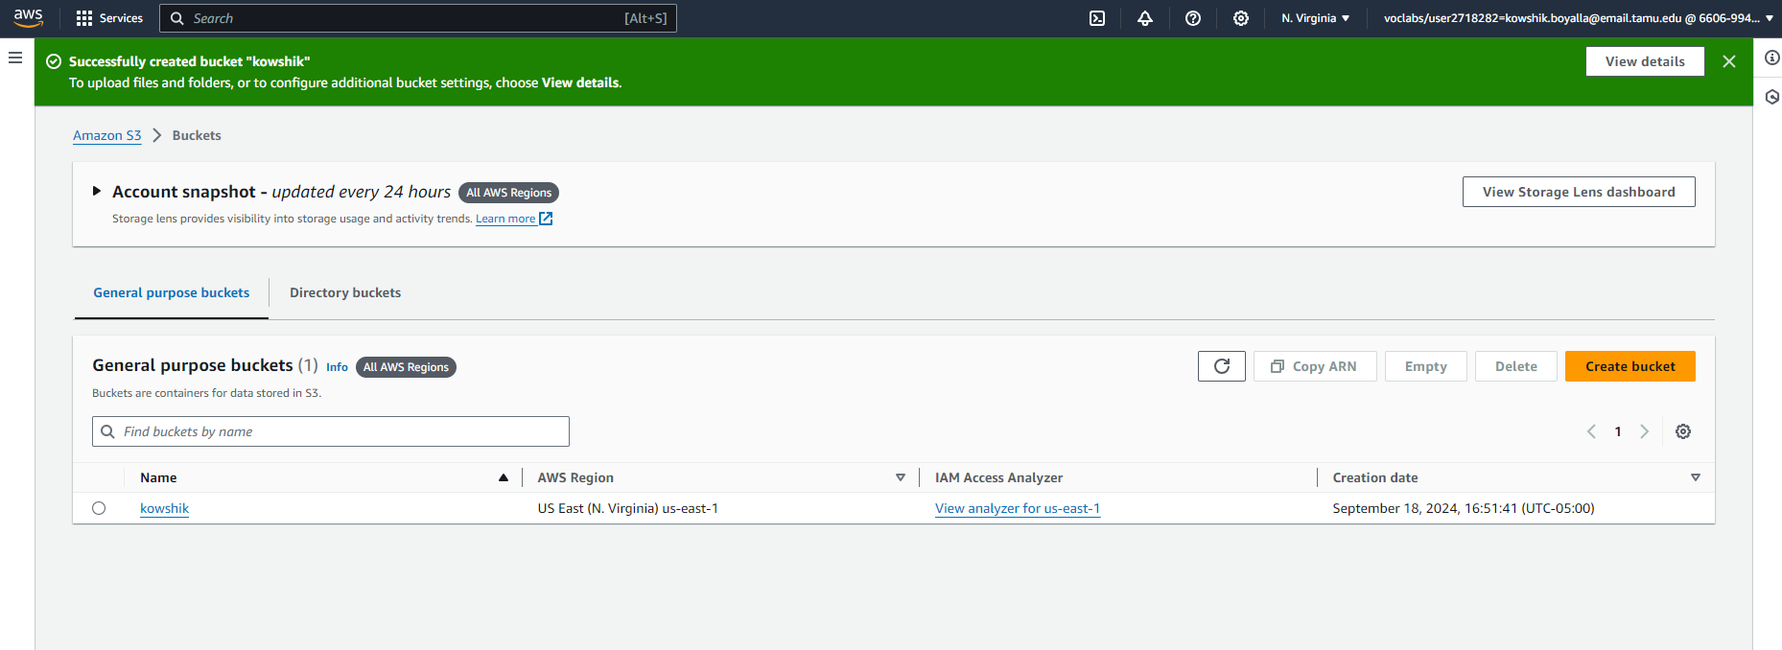

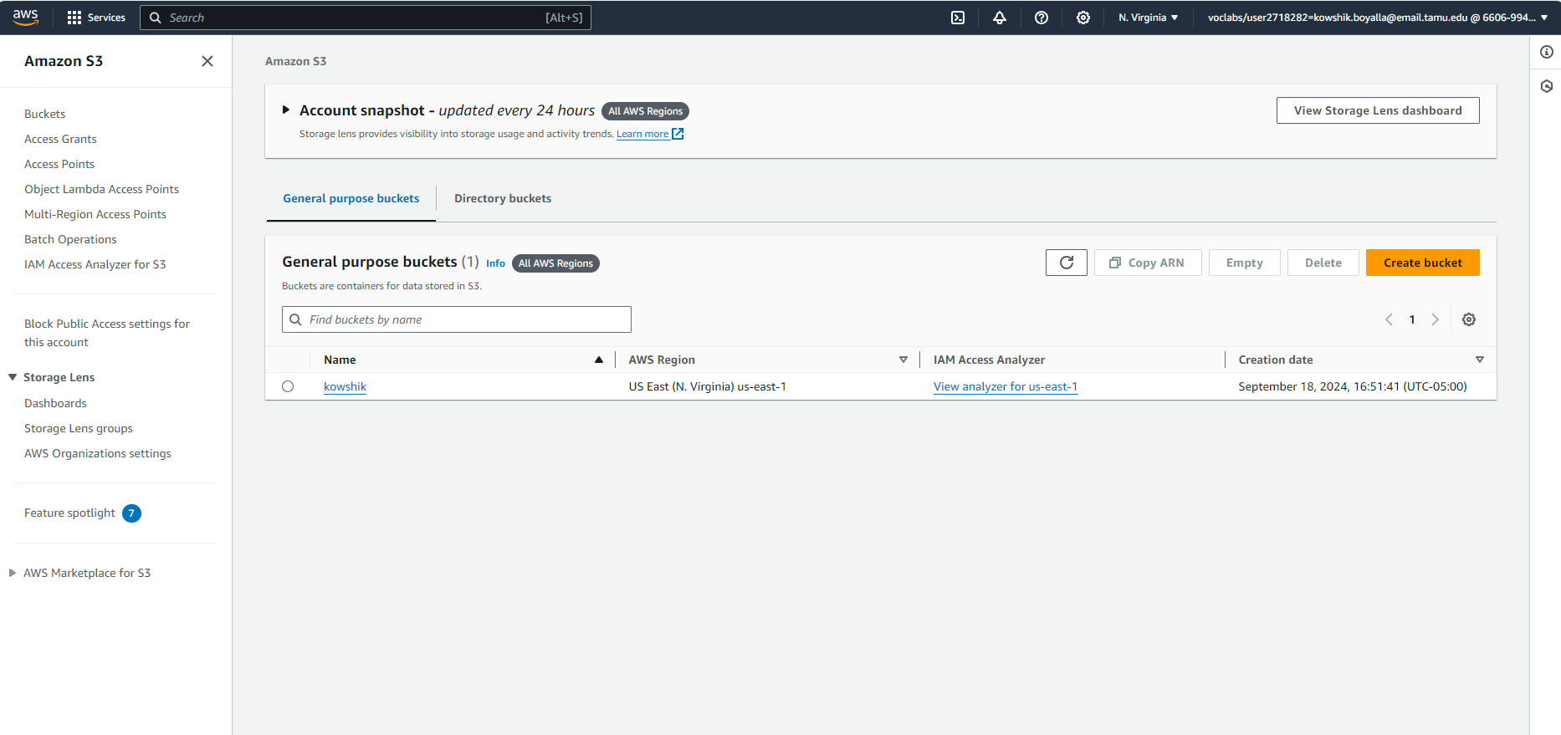

1. Uploading 2 files - sales_tab.txt and sales_pipeline_short-version.csv.

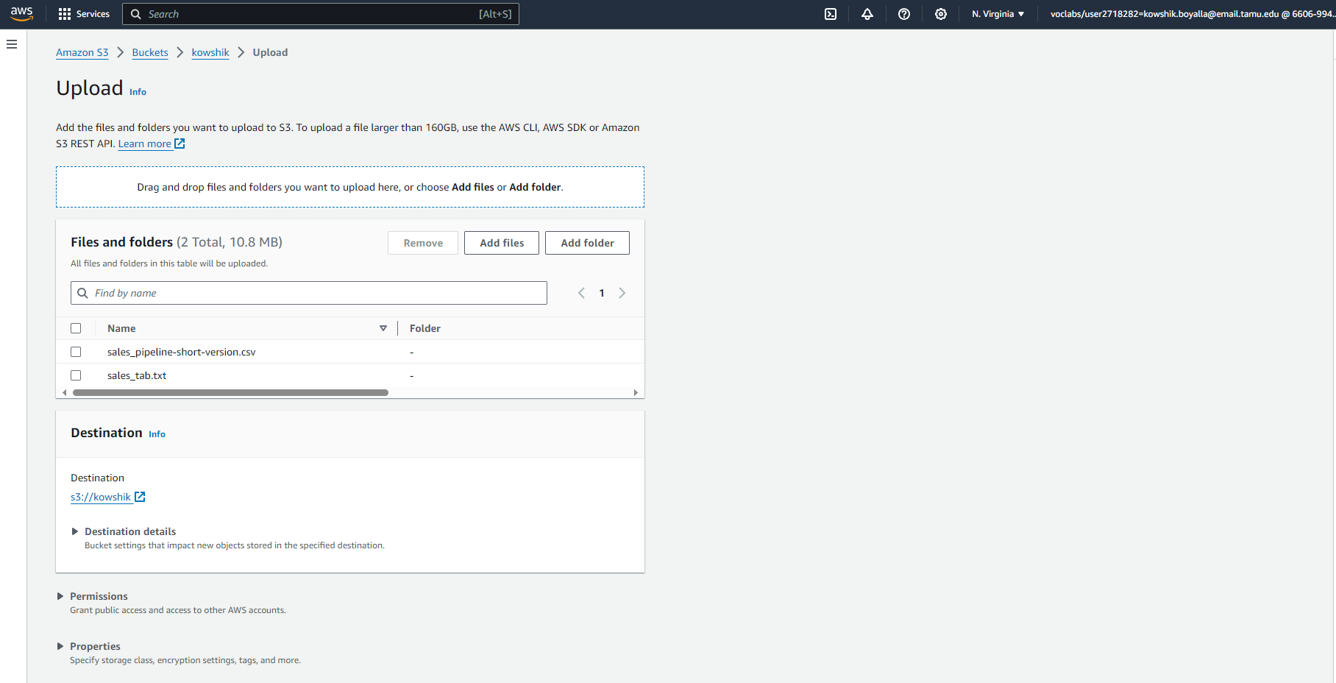

1. Uploaded files successfully.

